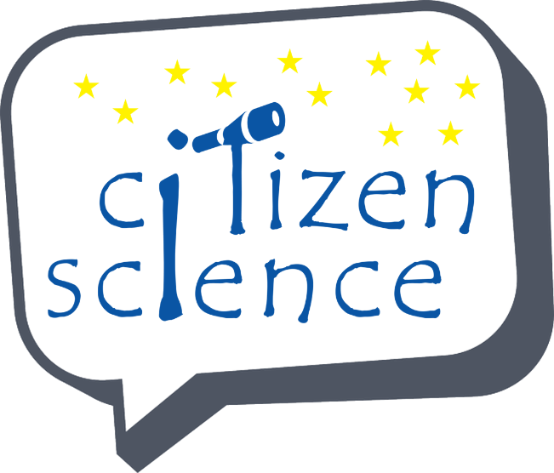
Data Management in Citizen Science Projects: share your experience

It has been recognized that issues regarding the sustainability and interoperability of data collected by citizens hinder the re-usability and integration of these data across borders.
The European Commission’s Joint Research Centre (JRC), is following up on these findings with a detailed study of interoperability arrangements, hosting and data management practices of Citizen Science projects. These activities include a survey designed to capture the state of play with regard to data management practices on the local, national and continental scales. The questions are especially inspired by the recently proposed data management principles of the Group on Earth Observations and those of the Belmont Forum.

Beyond the pure stocktaking and awareness raising, the results should establish a base line for prioritising follow-up activities and measuring progress. The results will also inform the discussion on the potential roles of the European Commission – and especially the JRC – in Citizen Science.
After discussions with members of the European Citizen Science Association (ECSA) and the international Citizen Science Association (CSA), it was decided to open the scope of the questionnaire to the international community, so that non-EU and globally acting organisations could also benefit from the outcomes.
The survey will be open until 31 August 2015. The results of the subsequent analysis will be available by the end of September.
We invite all those involved in Citizen Science projects to take the survey in order to provide us with invaluable information and insight into Citizen Science projects and best practice.
Take the Survey! https://ec.europa.eu/eusurvey/runner/CSDataManagement
Contact point: Sven SCHADE (sven.schade@jrc.ec.europa.eu)
European Commission - DG Joint Research Centre

